# HARI AND DEEPTI

## 

A husband a wife duo, Hari and Deepti create cut paper lightboxes that illustrate fairy tales inspired by stories they have acquired from cultures all over Europe and Asia. “Finding collaborative common ground in a paper medium, the couple merge their personal artistic backgrounds in creation of layered ethereal worlds and dioramas inspired by Wes Anderson, Hayao Miyazaki, Jules Verne, nature scenes, and travel” (the Shorty Awards)Originally working in Denver, the pair now live and work in Mumbai, India. They have created work displayed in windows, galleries, festivals, and have even painted four large scale murals. The couple is inspired by the way layered paper and light interact to create a simple, yet intricate form when lit up. (*artist*)

“Paper is brutal in its simplicity as a medium. It demands the attention of the artist while it provides the softness they need to mold it in to something beautiful. It is playful, light, colorless and colorful. It is minimal and intricate. It reflects light, creates depth and illusions in a way that it takes the artist through a journey with limitless possibilities.” -Hari and Deepti

## Conceptual Framework (guiding discussion)

Subjective: What do you think of when you first see the images created by Hari and Deepti? What are the images saying/are they telling a story? How do you feel about these works?

Cultural: What part of the *world* do you think these stories are from? Are they all from the same region or do you think they differ? What part do stories/fairy tales play in a culture/belief system? How is the element of storytelling used in each piece?

Structural: Just by looking at the work, what sort of process/materials do you think are being used? What symbols are being used in the artwork, and how are they being used? How are the artists using composition to enhance their story telling? (How does repetition take the eye around the work? How is framing used to create a viewpoint?) How does the use of layering with positive/negative space impact the way light shines through the piece?

**“Each piece feels like an elaborate vignette, carved from the storybook of their shared imaginations” -Fine Print NYC**

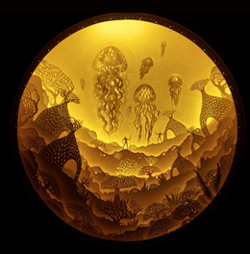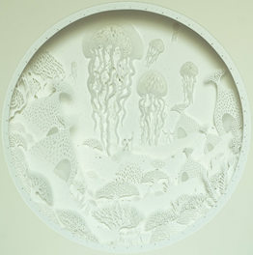

Hari and Deepti, *Nautilus* 2017

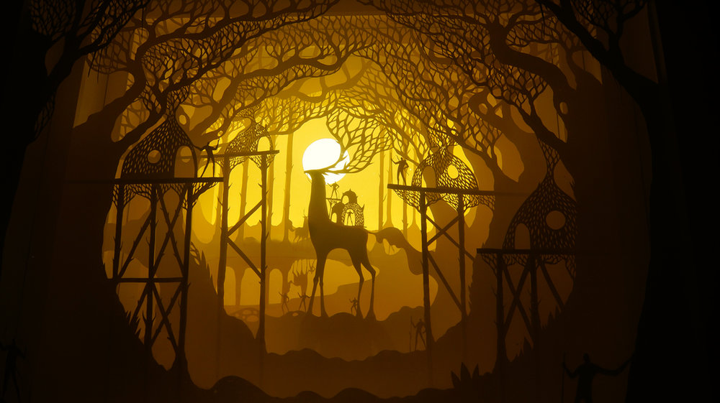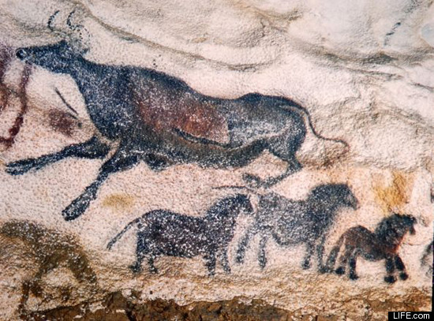

Hari and Deepti, *Nomadic Dwellers* 2016 Lascaux cave drawings, c. 17000 BCE

Activity:

Have students compare/contrast Hari and Deepti’s work with the Lascaux cave paintings. How are they similar/different? What materials are used to make each? How do we tell stories today? What forms of storytelling are there? Why do you think the cave paintings were made the way they were? Do we still tell the same kinds of stories, or have the stories themselves changed as well?

After comparing the work, ask the students to come up with a simple story to illustrate in both styles. They will not create a lightbox, however they will analyze the style of Hari and Deepti’s figures, composition, colors, etc. and create a colored pencil piece using those elements. For the cave paintings they will use conte crayons on gray paper. Once finished with both pieces, the students will share their work with the class, as well as share which way of storytelling they enjoyed more/why.

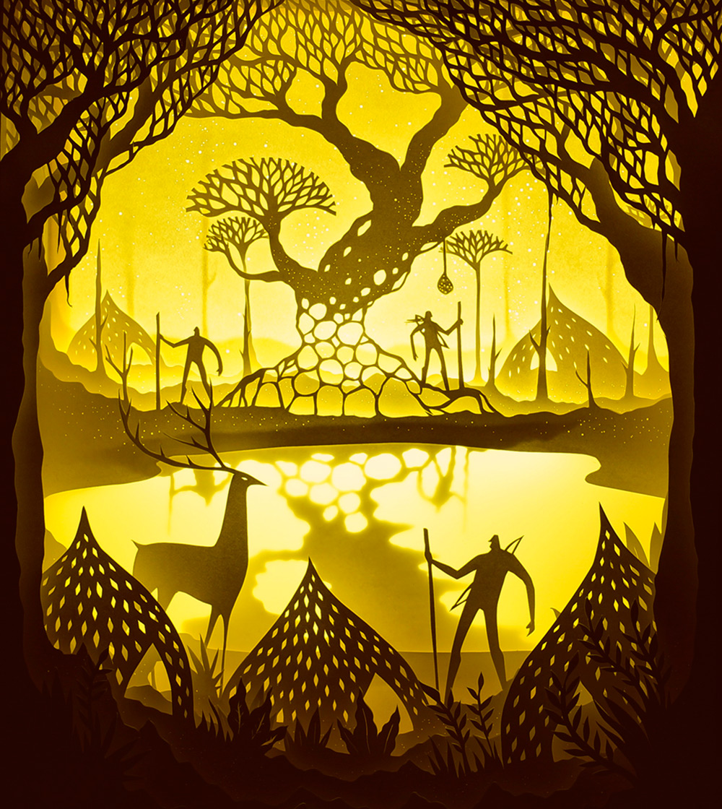

By creating cut paper, illuminated light boxes, Hari and Deepti bring a new outlook on storytelling. The beautiful light boxes bring forth a sense of adventure and fantasy that enhances each story they tell, while also bringing a feeling of mystery and awe to the viewer. The fantastical creatures and elongated figures are out of this world, yet are familiar at the same time, leaving the viewer wanting to figure out the story and know more. (*audience*) Though completely stagnant, each piece feels like a frame from an incredibly beautiful movie that could play at any moment. “What amazes us about the paper cut light boxes is the dichotomy of the piece in its lit and unlit state, the contrast is so stark that it has this mystical effect on the viewers”- Hari and Deepti about their use of materials. (*artwork)*

Hari and Deepti started working with watercolor on colored paper, making layered scenes before working monochromatically with simple white paper illuminated by light to create depth and value. How do you think the work would feel if it were created in color? What do the illuminated scenes do for the work? Does it create a different mood, different feelings, content, etc.?

Hari and Deepti, *Aura the Spirit Tree* 2015

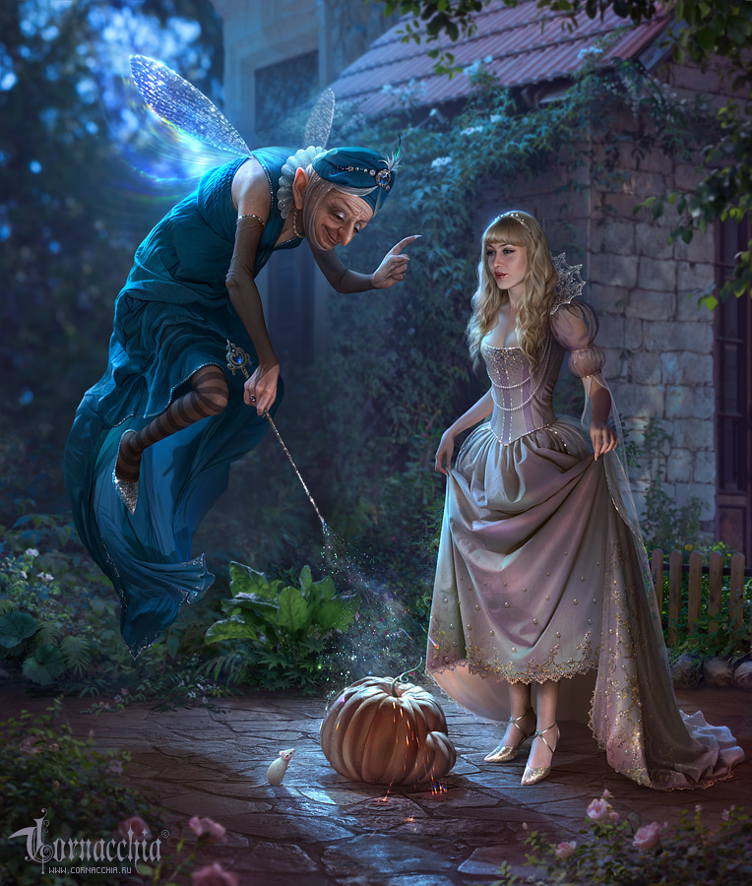

To the right is the digital artwork of Olga Cornacchia. What are your first thoughts about it? Do you know what fairytale is being depicted? How does this way of illustrating differ from Hari and Deepti? Which do you prefer? What is important about the process of using digital work for this style? Would the work be different if it were an oil painting?

Olga Cornacchia, *Decorating Fabric* n.d.

Digital Art Activity:

As a great exercise, have students play around with layering in Adobe Illustrator/Photoshop. Have the students create a scene from a fairytale of their choice and illustrate that scene using digital resources. Because this is just an exercise, encourage the students to only use the shape tool to create basic shapes and then choose one color to use as a gradient throughout the layers to give the illusion of light/depth.

How does this relate to the work of Hari and Deepti? Why is this a good exercise to begin with before making a physical light box?

Vocabulary:

Layering- to overlap material to create a form

Illustrate- to use drawings, pictures, etc. in order to explain or narrate a story

Fairytale- a story, usually for children, about elves, hobgoblins, dragons, fairies, or other magical creatures that usually communicates a moral message

Lightbox- a box form constructed in order to allow light to pass through it to create an image

**Cut Paper Lightboxes**

The students will create their own lightbox, illustrating an important scene from a story/fairytale of their choice. They must include at least three layers of paper and create the illusion of depth/space.

Materials: White cardstock paper, vellum, tacky glue, examples of silhouettes, pencils, sketch paper (or VPJ), and teacher example

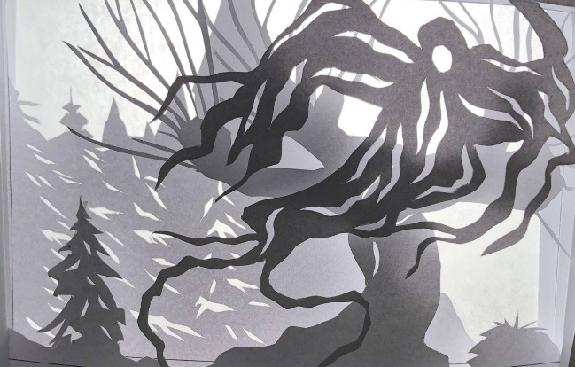Prior to creating their cut-paper lightboxes, allow students to write, draw, and research in their Visual Journals. Show students not only the teacher example, but give them resources to videos with the process of creating a cut-paper lightbox.

A few great videos to show the process:

<https://youtu.be/7ZOXIcCxtCs>

<https://youtu.be/Dq7S1qWmZS4>

<https://youtu.be/NPbtI39k_rs>

**Resources:**

https://cornacchia.ru/gallery/zolushka-2/

https://www.fineprintart.com/art/hari-and-deepti-papercut-dioramas

https://shortyawards.com/9th/iratherdraw

http://www.harianddeepti.com/